October X, 2015

Dear Editor,

Please consider our manuscript entitled “Invasive ungulates are major drivers of forest composition in avian-free novel ecosystems” for publication as a research paper in Proceedings of the Royal Society B. This study investigates the ecological roles of ungulates, normally notorious invasive species in island native systems, in the highly altered avian-free novel ecosystems of Guam and the neighboring island of Rota.

We used field and nursery experiments to determine the role of Philippine deer (*Rusa mariannae*) and feral pigs (*Sus scrofa*) in plant communities of limestone karst forest. This work showed that while feral pigs are capable of ecological damage in many other systems, because of their capability as seed dispersers, they may have a beneficial role in a novel ecosystem that has lost this important ecological service. However, deer, also ecologically damaging in other systems, strongly shape forest characteristics by suppressing forest regeneration, even at low abundances. While ecological studies on non-native species has long focused on their detrimental roles, our work presents a unique situation where a species that would have been considered principally harmful in the same system just decades before, now potentially offers a crucial ecological service. Pigs in this system have not taken on new ecological roles, they have become the remaining vertebrate dispersers in an island that has lost the native species that shared this role. Meanwhile, we affirm that deer continue to negatively impact these systems.

We believe that our paper will appeal to readers of Proceedings of the Royal Society B and spark future research on novel ecosystems and shifting ecological roles of species within them. Further, we hope that more similar research will encourage conservation managers to look more closely at these roles and adaptively manage novel ecosystems instead of taking a more traditional approach that favors native species over non-natives, regardless of function.

Thank you for your time and consideration of our paper.

Sincerely,

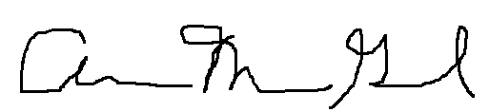

Ann Marie Gawel (on behalf of all authors)